**Table S1**: Differentially expressed upregulated genes identified by CRC bulk RNA sequencing analysis

| **Genes** | **P-value** | **logFC** |
| --- | --- | --- |
| MMP7 | 2.9139149781976E-07 | 3.34801273320787 |
| DPEP1 | 4.78110613366667E-06 | 3.31039819479831 |
| CLDN1 | 9.80462599997622E-10 | 3.13884280298666 |
| SPP1 | 1.05626016710936E-07 | 3.13776252936119 |
| ALB | 0.0087945705444672 | 2.87355328101902 |
| APOA2 | 0.00278243593159611 | 2.8682673489616 |
| HP | 0.00762968662718921 | 2.80576134293485 |
| CXCL8 | 2.08544838065094E-08 | 2.80324624629453 |
| THBS2 | 8.44592655813159E-08 | 2.78446487928006 |
| H19 | 6.50145592575591E-05 | 2.75764910576636 |

**Table S2**: Differentially expressed downregulated genes identified by CRC bulk RNA sequencing analysis

| **Genes** | **P-value** | **logFC** |
| --- | --- | --- |
| CLCA4 | 9.39943678446298E-11 | -5.39286388569494 |
| CA1 | 5.88014081870369E-10 | -5.24494580028301 |
| AQP8 | 2.06184003204157E-09 | -5.06267938261109 |
| CA7 | 1.765254609154E-14 | -4.84516708661542 |
| GUCA2B | 3.29520855046894E-11 | -4.80463212592021 |
| GUCA2A | 1.52999968250356E-09 | -4.66202473106322 |
| CEACAM7 | 3.3172660951486E-08 | -4.25681325185364 |
| CLCA1 | 2.09625636826694E-06 | -4.22885265008177 |
| CA4 | 3.38351346940158E-10 | -4.13738856316774 |
| OTOP2 | 1.11022302462516E-16 | -3.97846541040323 |

**Table S3.** Significant biological processes of upregulated genes

| **Description** | **P-value** | **Genes** |
| --- | --- | --- |
| Negative regulation of endopeptidase activity | 1.10E-13 | ITIH3, SERPIND1, SERPINA10, SERPINA11, AHSG, SERPINA4, ITIH2, C5, HRG, C3, AMBP |
| Lipid metabolic process | 6.12418754002164E-07 | DHCR7, CYP2C8, DGAT2, SCD, DPEP1 |
| Chemotaxis | 5.93572794588528E-08 | CXCL11, SERPIND1, LECT2, S100A8, CXCL3 |
| Inflammatory response | 4.29597825009908E-07 | CXCL11, SPP1, IL1B, CRHBP, DPEP1 |
| Neutrophil chemotaxis | 7.86462234397606E-07 | CXCL11, IL1B, DPEP1, S100A8, CXCL3 |
| Proteolysis | 3.1633274035452E-09 | KLK6, F12, F7, MMP11, MMP1 |
| Angiogenesis | 0.000430161325751758 | ESM1, TNFRSF12A, COL4A2, FAP, EREG |
| Acyl-Coa Metabolic Process | 0.00702465131840229 | ACSM2B, BAAT, ACSM2A |
| Negative regulation of peptidase activity | 8.78E-08 | ITIH3, SERPIND1, SERPINA10, SERPINA11, SERPINA4, ITIH2, AMBP |
| Lipoprotein metabolic process | 1.59E-07 | APOM, APOA2, APOC3, OLR1, PCSK9, APOB, MTTP |

**Table S4.** Significant biological processes of downregulated genes

| **Description** | **P-value** | **Genes** |
| --- | --- | --- |
| Immunoglobulin production | 3.15E-18 | IGLV6-57, IGLV5-45, VPREB3, IGKV1-27, IGLV8-61 |
| Immune response | 6.57E-12 | CXCL13, IGLV6-57, BMP6, CD8A, NKX2-3 |
| Adaptive immune response | 1.09E-08 | CD79A, TNFRSF17, IGLV6-57, CD8A, IGLV5-45 |
| Positive regulation of B cell activation | 1.27E-06 | IGHV5-51, IGHV2-5, IGHV6-1, IGHV1-18, IGHV4-59 |
| Phagocytosis, recognition | 1.12E-06 | IGHV5-51, IGHV2-5, IGHV6-1, IGHV1-18, IGHV4-59 |
| Complement activation, classical pathway | 2.64E-06 | IGHV5-51, IGHV2-5, IGHV6-1, CR2, IGHV1-18 |
| B cell receptor signaling pathway | 3.96E-06 | CD79A, IGHV5-51, IGHV2-5, IGHV6-1, IGHV1-18 |
| Phagocytosis, engulfment | 9.01E-06 | IGHV5-51, IGHV2-5, IGHV6-1, IGHV1-18, IGHV4-59 |
| Proteolysis | 0.001083905 | FGL2, MEP1A, TPSAB1, CMA1, ADAM28, CTSE, CPA3 |

**Table S5**: Significant MF pathways of upregulated genes

| **Description** | **P value** | **Genes** |
| --- | --- | --- |
| Serine-type endopeptidase activity | 1.86E-12 | KLK6, F12, F7, MMP11, MMP1 |
| Serine-type endopeptidase inhibitor activity | 6.36E-11 | ITIH3, SERPIND1, SERPINA10, SERPINA11, SERPINA4 |
| Cytokine activity | 3.09E-10 | CXCL11, SPP1, IL1B, AREG, INHBB, CXCL3 |
| CXCR chemokine receptor binding | 1.71E-09 | CXCL11, CXCL3, CXCL6, CXCL10, CXCL1 |
| Heparin binding | 3.05E-09 | CXCL11, SERPIND1, COMP, SERPINA10, APOH |
| Extracellular matrix structural constituent | 7.61E-09 | COMP, FGA, MFAP2, FGB, COL11A1 |
| Endopeptidase inhibitor activity | 2.64E-08 | ITIH3, SERPIND1, AHSG, ITIH2, C5 |
| Growth factor activity | 7.39E-08 | AREG, INHBB, IGF2, INHBE, GDF15, CXCL1 |
| Peptidase inhibitor activity | 9.67E-08 | ITIH3, SERPIND1, SERPINA10, SERPINA11, SERPINA4 |
| Serine-type peptidase activity | 6.84E-07 | KLK6, F12, F7, C2, F9 |

**Table S6**: Significant MF pathways of downregulated genes

| **Description** | **P-value** | **Genes** |
| --- | --- | --- |
| Antigen binding | 2.13E-15 | IGLV6-57, IGHV5-51, MFAP4, IGHV2-5, IGHV6-1, |
| Immunoglobulin receptor binding | 3.75E-08 | IGHV5-51, IGHV2-5, IGHV6-1, IGHV1-18, IGHV4-59, |
| Extracellular matrix structural constituent | 2.29E-06 | FGL2, SRPX, CILP, COL17A1, SPON1 |
| Hormone activity | 1.39E-05 | UCN3, EDN2, CHGB, NPY, GCG |
| Galactoside binding | 1.53E-05 | LGALS9B, LGALS4, LGALS9C, LGALS2 |
| Carbonate dehydratase activity | 0.000151 | CA1, CA2, CA7, CA4 |
| Hexosyl transferase activity | 0.000238 | GGTA1, B3GNT7, B3GALT5, B3GNT6, B4GALNT2 |
| Peptidase activity | 0.000278 | FGL2, MEP1A, TPSAB1, CMA1, ADAM28 |
| Guanylate cyclase activator activity | 0.000364 | GUCA2B, GUCA2A |
| Symporter activity | 0.000439 | SLC15A1, SLC1A1, SLC13A2, SLC4A4, SLC36A1 |

**Table S7**: Significant CC pathways of upregulated genes

| **Description** | **P-value** | **Genes** |
| --- | --- | --- |
| Extracellular region | 8.13E-48 | HAMP, KLK6, F12, AZGP1, FJX1 |
| Collagen-containing extracellular matrix | 2.60E-23 | F12, AZGP1, COMP, F7, FGA |
| Blood microparticle | 7.51E-18 | FGA, ALB, FGB, APCS, AHSG |
| Extracellular exosome | 4.00E-17 | F12, AZGP1, ITIH3, SERPIND1, COMP |
| Endoplasmic reticulum lumen | 1.66E-15 | SERPIND1, F7, FGA, SPP1, STC2 |
| Platelet alpha granule lumen | 1.33E-13 | FGA, ALB, FGB, IGF2, AHSG |
| Extracellular matrix | 2.07E-10 | COMP, MMP11, MMP1, COL11A1, THBS2 |
| High-density lipoprotein particle | 4.75E-09 | APOM, APOH, APOA2, SAA4, APOF |
| Platelet alpha granule | 1.70E-07 | FGA, FGB, THBS2, FGG, F5 |
| Collagen trimer | 3.10E-07 | MMP1, MARCO, COL11A1, COL4A2, CTHRC1 |

**Table S8**: Significant CC pathways of downregulated genes

| **Description** | **P-value** | **Genes** |
| --- | --- | --- |
| Immunoglobulin complex | 5.02E-17 | IGLV6-57, IGLV5-45, IGKV1-27, IGLV8-61, IGLV2-33 |
| Collagen-containing extracellular matrix | 9.69E-11 | FGL2, SPARCL1, SFRP2, F13A1, LGALS4 |
| Extracellular exosome | 5.24E-10 | FGL2, GPD1L, MEP1A, SIAE, KRT19 |
| Immunoglobulin complex, circulating | 4.35E-07 | IGHV5-51, IGHV2-5, IGHV6-1, IGHV1-18, IGHV4-59 |
| Plasma membrane | 1.74E-06 | CD79A, AQP8, SLC15A1, GPD1L, FOLR2 |
| Apical plasma membrane | 2.87E-06 | SLC15A1, CEACAM1, MAL, CLIC5, CNTFR |
| Secretory granule | 0.000191 | CMA1, CHGB, CPA3, KLK1, CCL28 |
| Peptidase complex | 0.001133 | TPSAB1, TPSB2 |
| Microfibril | 0.001842 | MFAP4, MFAP5, LTBP4 |
| Basolateral plasma membrane | 0.002009 | SLC51B, ADRA2A, SLC51A, CLDN8, HPGD |

**Table S9**: Significant KEGG pathways of upregulated genes

| **Description** | **P-value** | **Genes** |
| --- | --- | --- |
| Complement and coagulation cascades | 2.47E-16 | F12, SERPIND1, F7, FGA, C2, FGB, CFHR5, F9, C6, C5, C3 |
| IL-17 signaling pathway | 3.34E-08 | IL1B, MMP1, S100A8, CXCL3, CXCL6, CXCL10 |
| Rheumatoid arthritis | 8.49E-06 | IL1B, MMP1, CXCL3, ATP6V1C2, CXCL6, CXCL1, CXCL2, VEGFA, MMP3, IL6, CXCL8 |
| Amoebiasis | 2.32E-05 | IL1B, CXCL3, COL4A2, CXCL1, CXCL2, ARG1, COL4A1, IL6, CXCL8, C8B, C8A |
| Alcoholic liver disease | 2.78E-05 | IL1B, SCD, C2, CXCL3, CXCL1, C5, CXCL2, ADH4, C3, LBP, IL6, CXCL8, CYP2E1 |
| TNF signaling pathway | 0.000292801 | IL1B, CXCL3, CXCL6, CXCL10, CEBPB, CXCL1, CXCL2, MMP9, MMP3, IL6 |
| Bile secretion | 4.20E-05 | NR0B2, SLC22A1, SLC10A1, BAAT, SLC22A7, UGT2B4, SLC27A5, SULT2A1, SLC2A1, AQP9 |
| PPAR signaling pathway | 5.45E-05 | MMP1, SCD, PLIN2, CYP8B1, APOA2, APOC3, SLC27A5, OLR1, FABP6 |
| Cytokine-cytokine receptor interaction | 0.000526405 | CXCL11, IL1B, TNFRSF12A, INHBB, CXCL3, INHBE, GDF15, CXCL6 |
| Biosynthesis of amino acids | 0.000327 | ALDOB, PYCR1, MAT1A, CPS1, PSAT1, ARG1, PHGDH, PAH |

**Table S10**: Significant KEGG pathways of downregulated genes

| **Description** | **P-value** | **Genes** |
| --- | --- | --- |
| Bile secretion | 1.32E-05 | AQP8, SLC51B, ATP1A2, UGT1A8, PRKACB |
| Proximal tubule bicarbonate reclamation | 8.74E-05 | PCK1, ATP1A2, CA2, SLC4A4, CA4 |
| Nitrogen metabolism | 0.000336428 | CA1, CA2, CA7, CA4 |
| Pentose and glucuronate interconversions | 0.00060156 | CRPPA, UGP2, UGT1A8, UGT2A3, UGDH |
| Renin-angiotensin system | 0.0011366 | CMA1, CPA3, KLK1, CTSG |
| Mineral absorption | 0.001399141 | ATP1A2, MT1F, MT1E, CYBRD1, MT1H, MT1G |
| Protein digestion and absorption | 0.005269487 | SLC15A1, MEP1A, ATP1A2, COL17A1, CPA3, SLC1A1, SLC36A1 |
| Pancreatic secretion | 0.004995902 | ATP1A2, CPA3, CA2, CLCA1, SLC4A4, SLC9A1, CLCA4 |
| Neuroactive ligand-receptor interaction | 0.005936979 | UCN3, VIPR1, EDN2, ADRA2A, NPY |
| Aldosterone-regulated sodium reabsorption | 0.006778452 | NR3C2, ATP1A2, NEDD4L, SCNN1B |

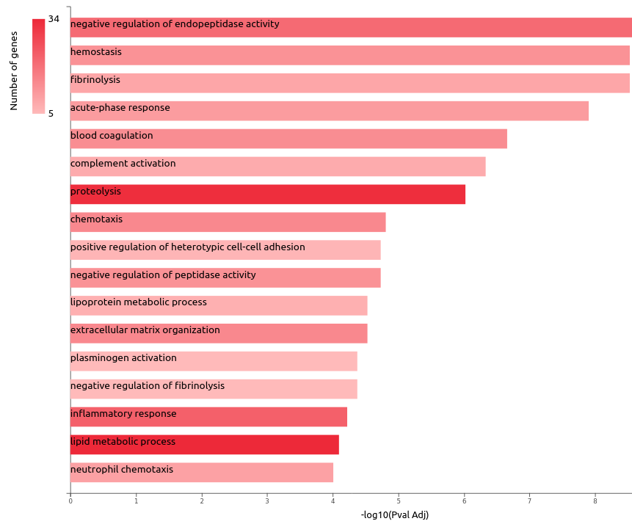

**Figure S1.** GO biological processes of upregulated genes. Barchart plot of top 20 BP in tumor vs. normal. The x-axis is the –log10(Pval Adj), while the gene number for each BP is represented on the y-axis. It represents the proteolysis and lipid metabolic process as significant BP.

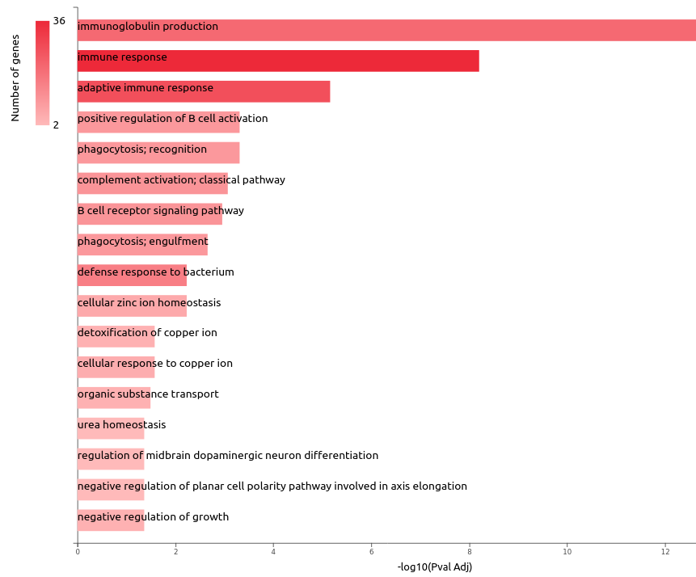

**Figure S2.** GO biological processes of downregulated genes. Barchart plot of top 20 BP in tumor vs. normal. The x-axis is the –log10(Pval Adj), while the gene number for each BP is represented on the y-axis. It represents immune response and adaptive immune response as significant BP.

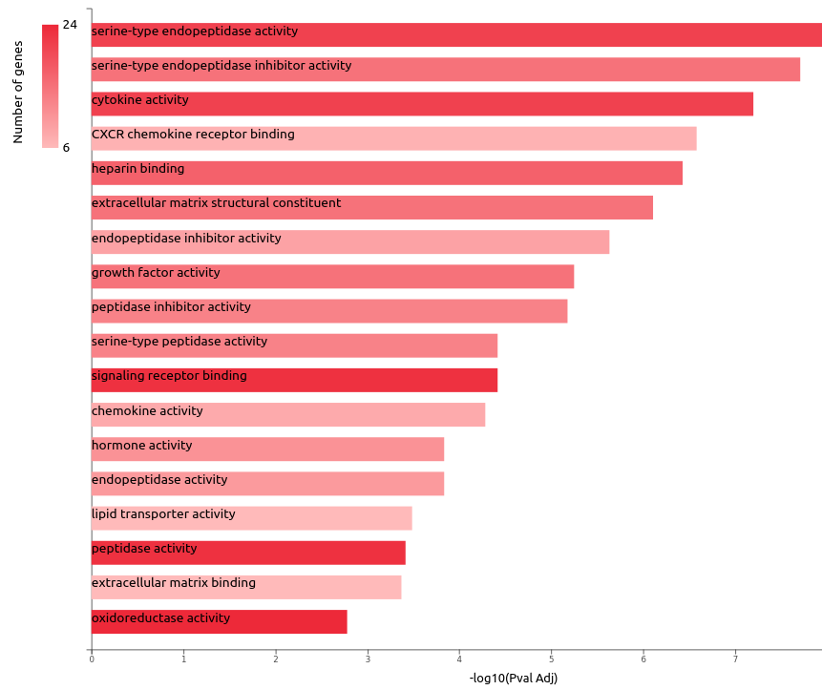

**Figure S3.** GO molecular functions of upregulated genes. Barchart plot of top 20 MF in tumor vs. normal. The x-axis is the –log10(Pval Adj), while the gene number for each MF is represented on the y-axis. It represents cytokine activity, serine-type endopeptidase activity, signaling receptor binding, peptidase activity, and oxidoreductase activity as a significant MF.

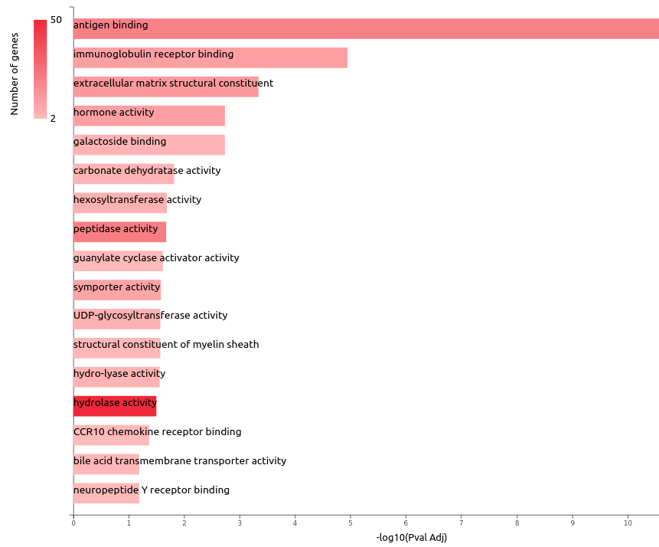

**Figure S4.** GO molecular functions of downregulated genes. Barchart plot of top 20 MF in tumor vs. normal. The x-axis is the –log10(Pval Adj), while the gene number for each MF is represented on the y-axis. It represents hydrolase activity as a significant MF

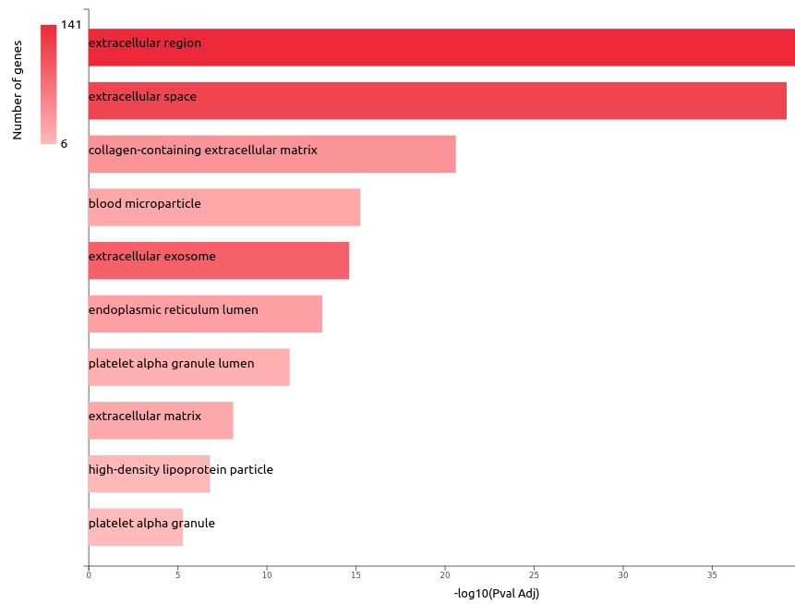

**Figure S5.** GO cellular components of upregulated genes—bar chart plot of top 20 CC in tumor vs. normal. The x-axis is the –log10(Pval Adj), while the gene number for each CC is represented on the y-axis. It represents extracellular region and space as significant CC.

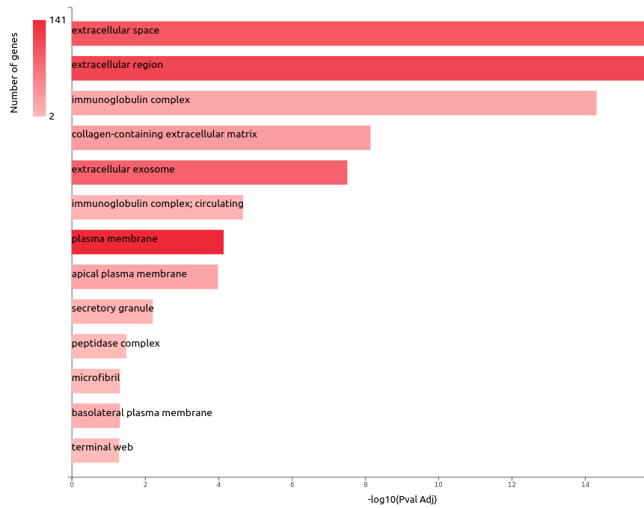

**Figure S6.** GO cellular components of downregulated genes—bar chart plot of top 20 CC in tumor vs. normal. The x-axis is the –log10(Pval Adj), while the gene number for each CC is represented on the y-axis. It represents the extracellular region and plasma membrane as significant CC.

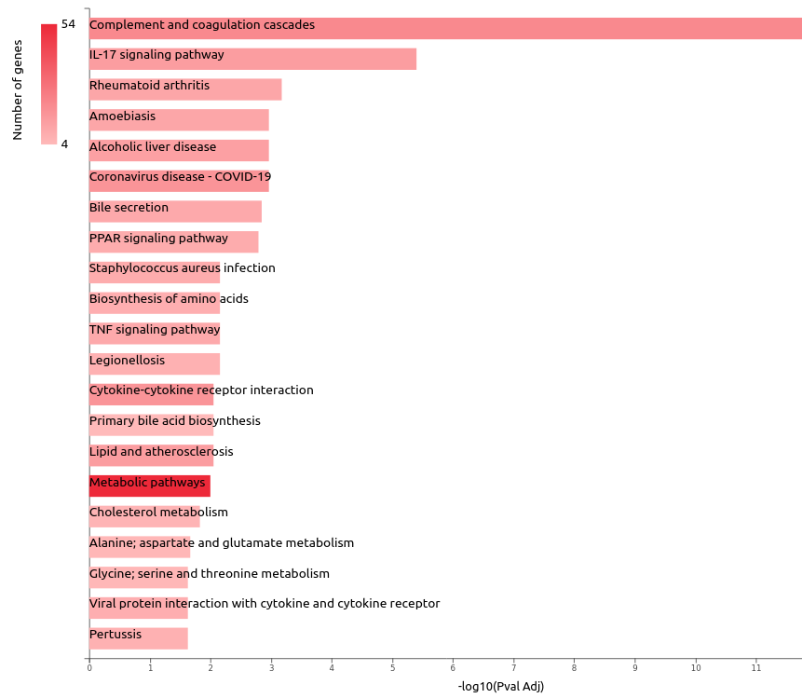

**Figure S7.** KEGG pathway analysis of upregulated genes. Barchart plot of top 20 pathways in tumor vs. normal. The x-axis is the –log10(Pval Adj), while the gene number for each pathway is represented on the y-axis.

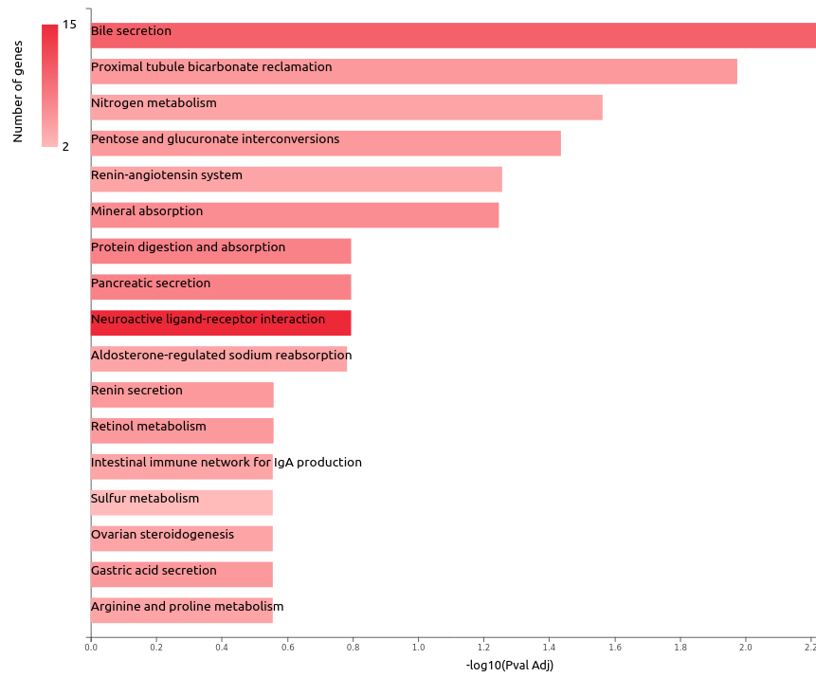

**Figure S8.** KEGG pathway analysis of downregulated genes. Barchart plot of top 20 pathways in tumor vs normal. The x-axis is the –log10(Pval Adj), while the gene number for each pathway is represented on the y-axis.